**Build a Serverless Real-Time Data Processing App**

Time spent: 150min

Application Overview

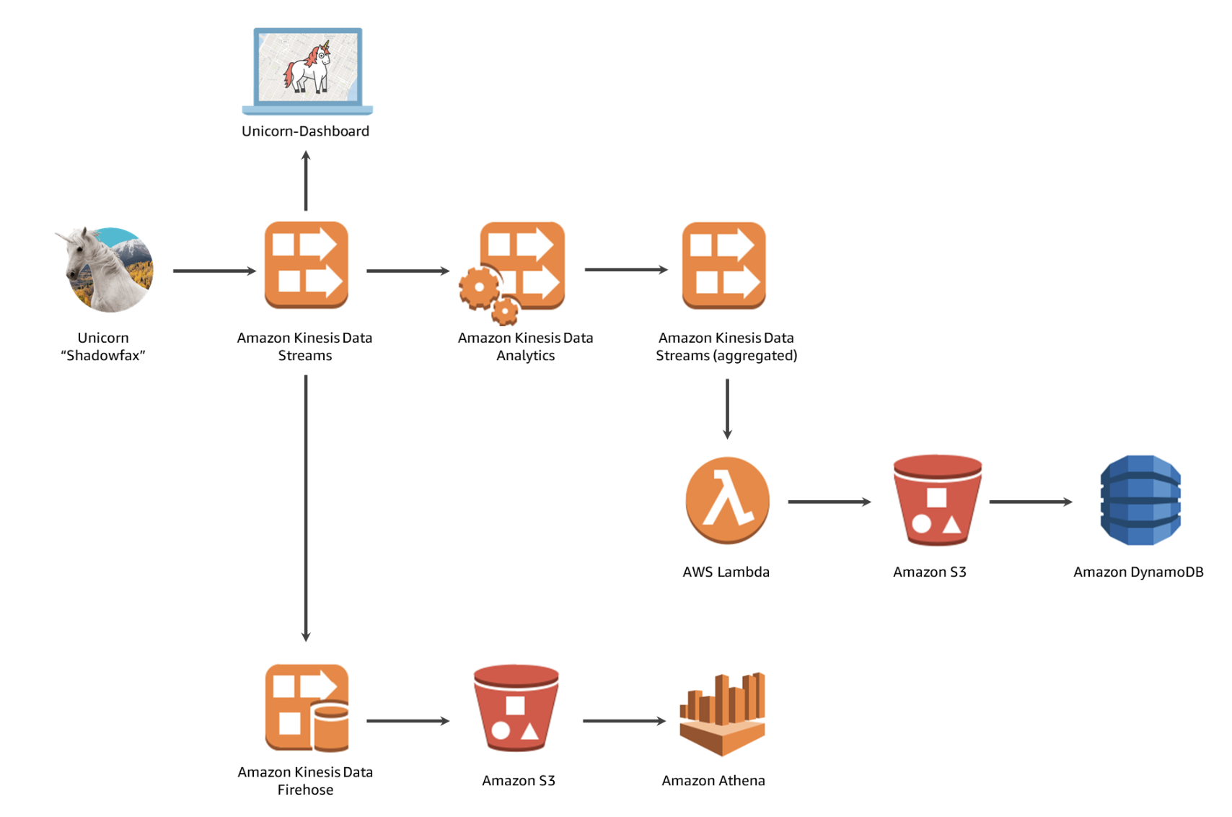

**Related components**:

* AWS Lambda
* Amazon Kinesis
* Amazon S3
* Amazon DynamoDB
* Amazon Cognito
* Amazon Athena

**What I learned:**

* How to build a real-time streaming data by Kinesis
* How to use Amazon Cloud9 IDE
* How to create new role in Amazon IAM and new policy
* How to build data analytics application on Kinesis
* How to read the message by application on Kinesis
* How to build the Lambda function
* Use Amazon Athena table to query raw data

**What I built:**

* Initiate the Cloud9 environment

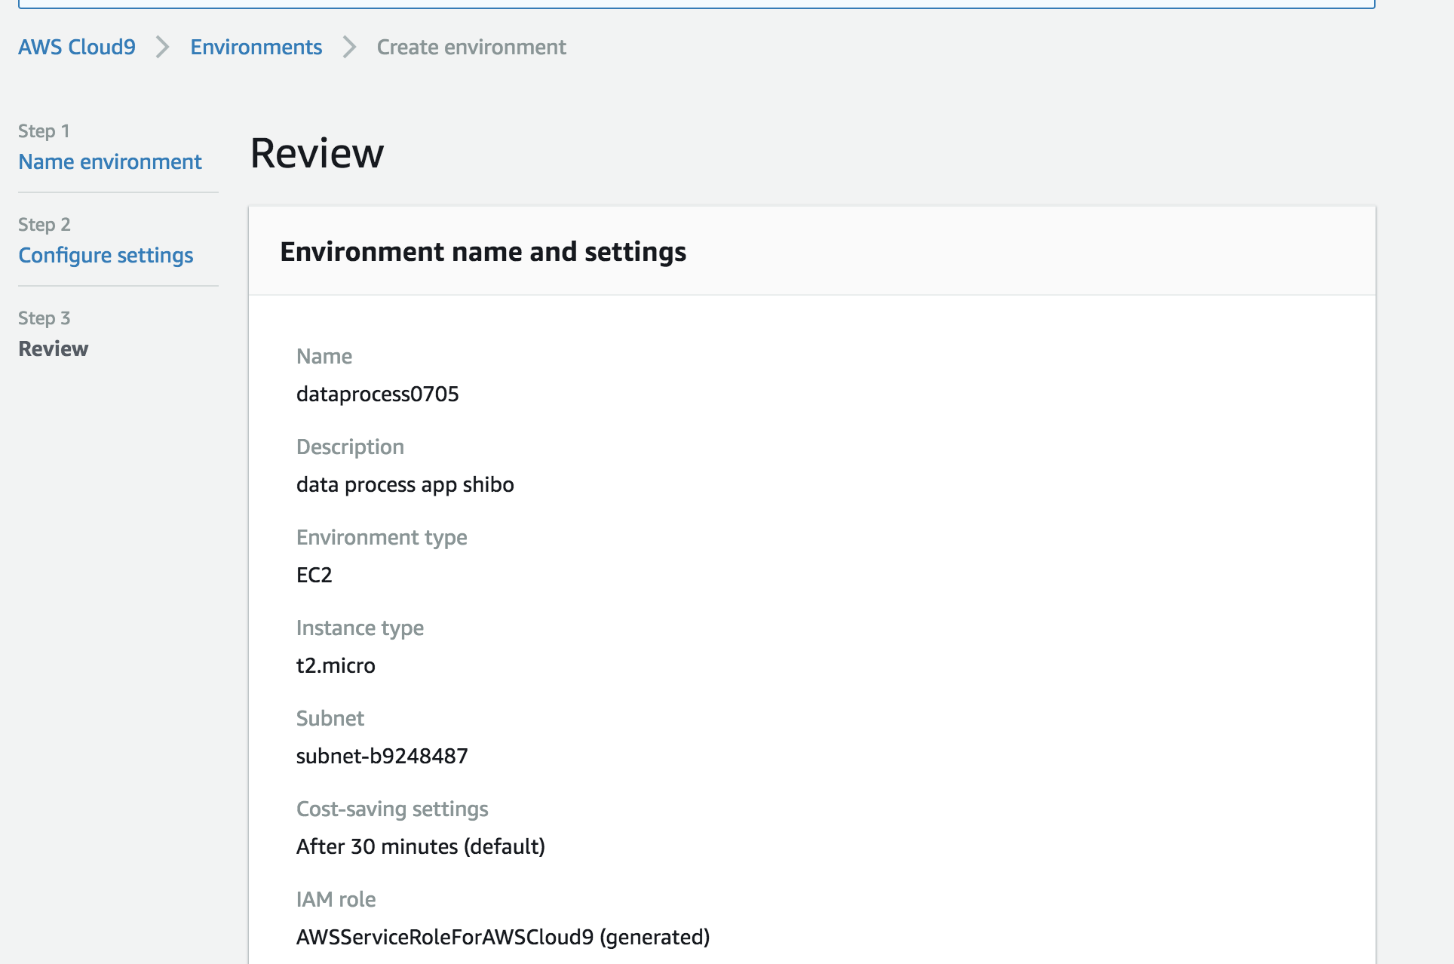 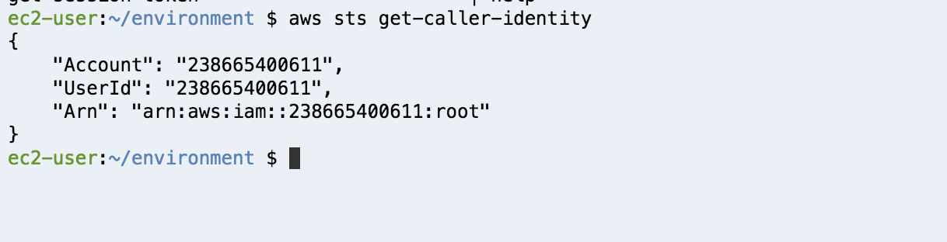

* Build the data stream by Kinesis, consumer can get the data

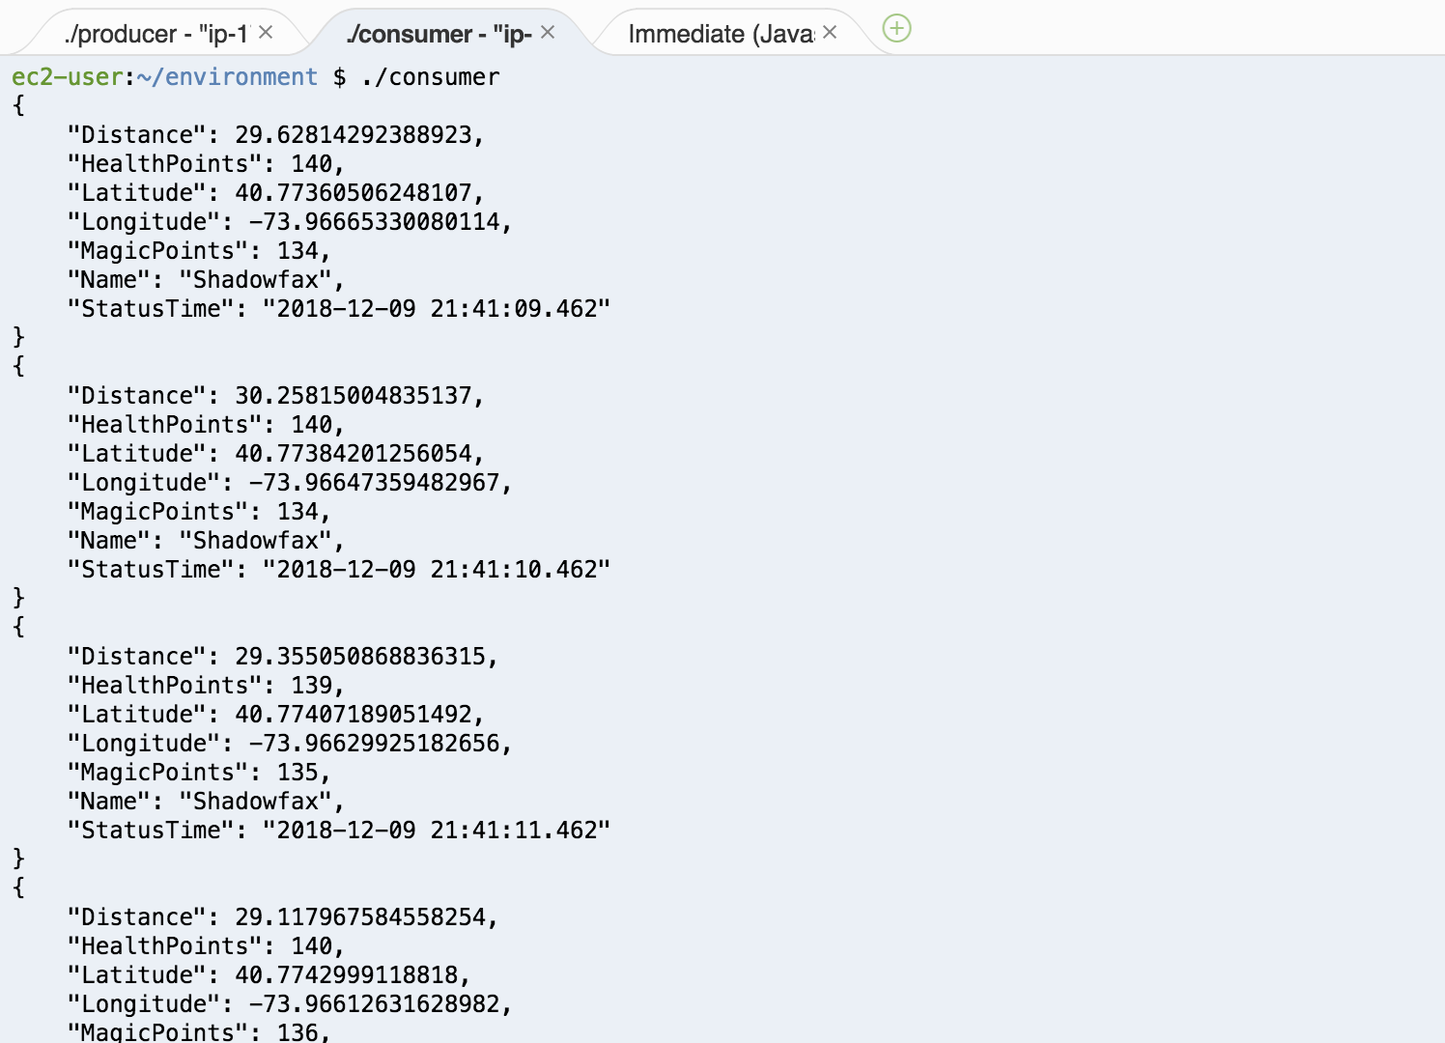

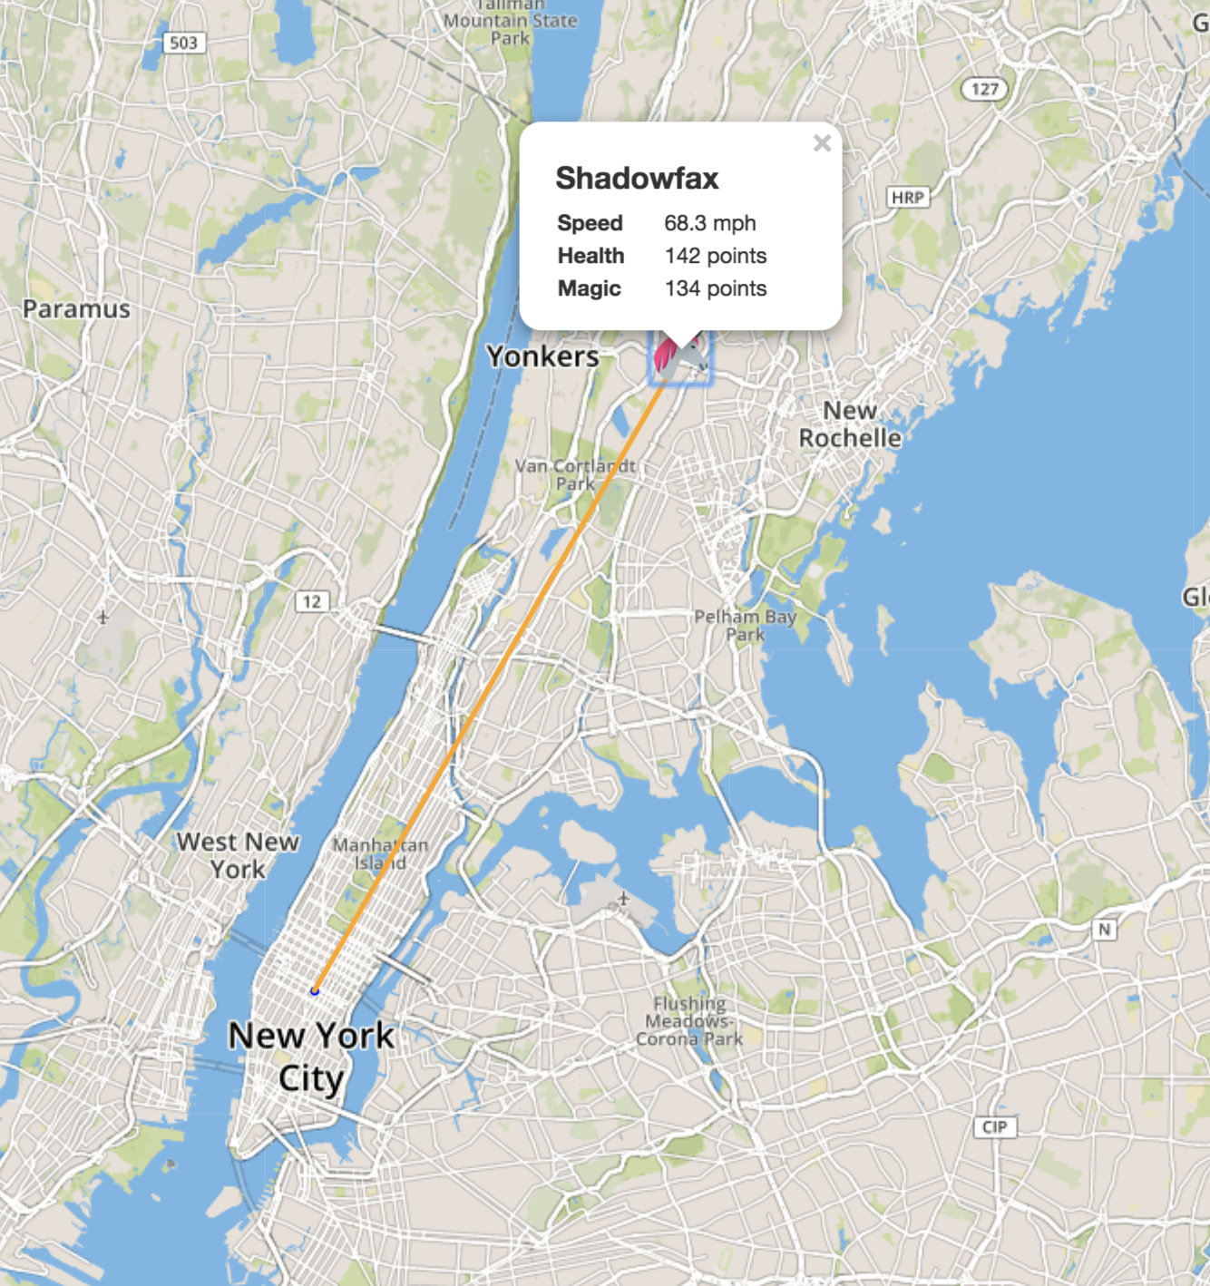

* Create a new authentication role

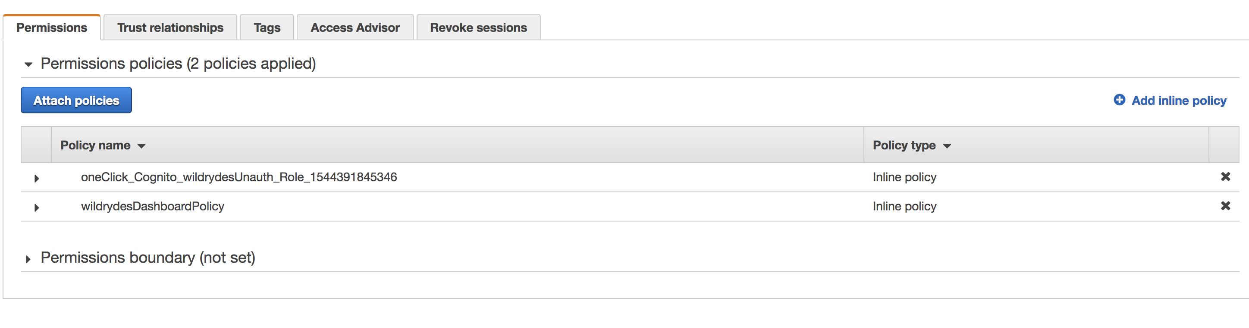

* Create two data stream to get multiple unicorns on the map

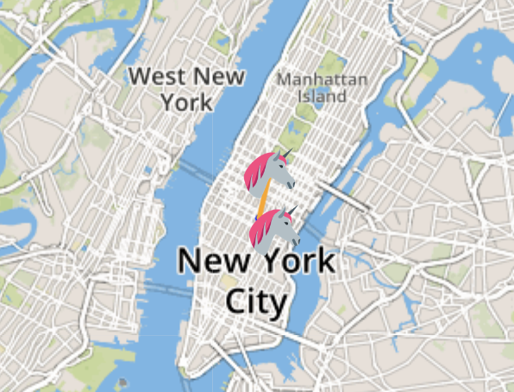

* Read message from the stream

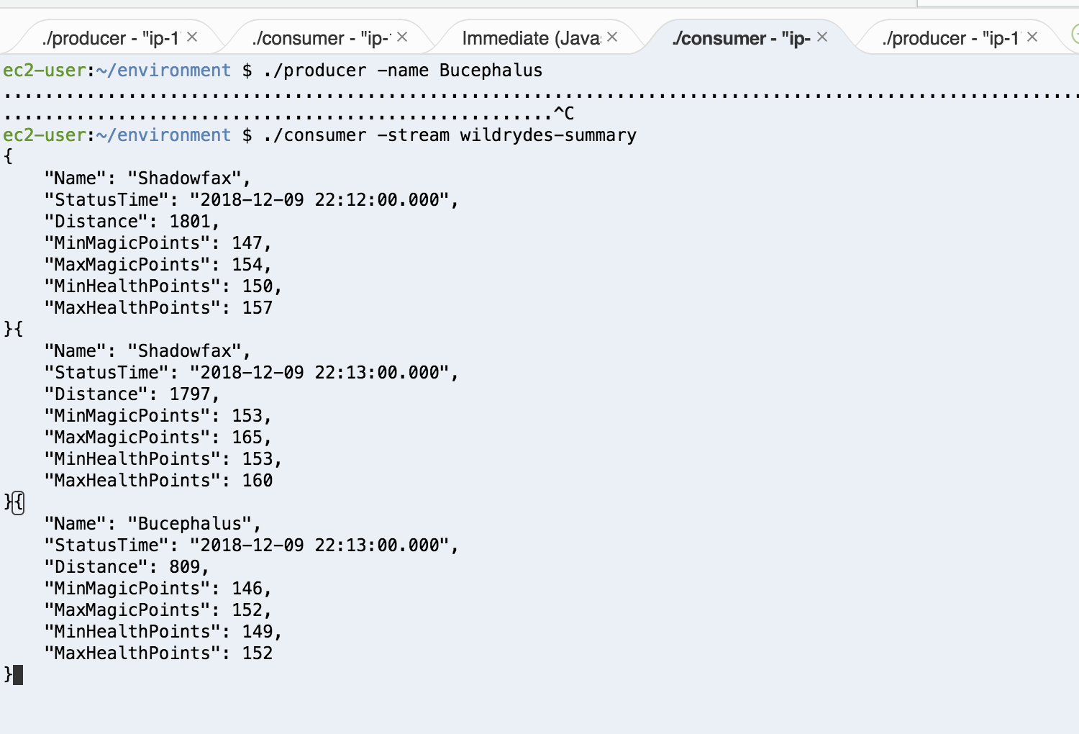

* Build the Lambda function

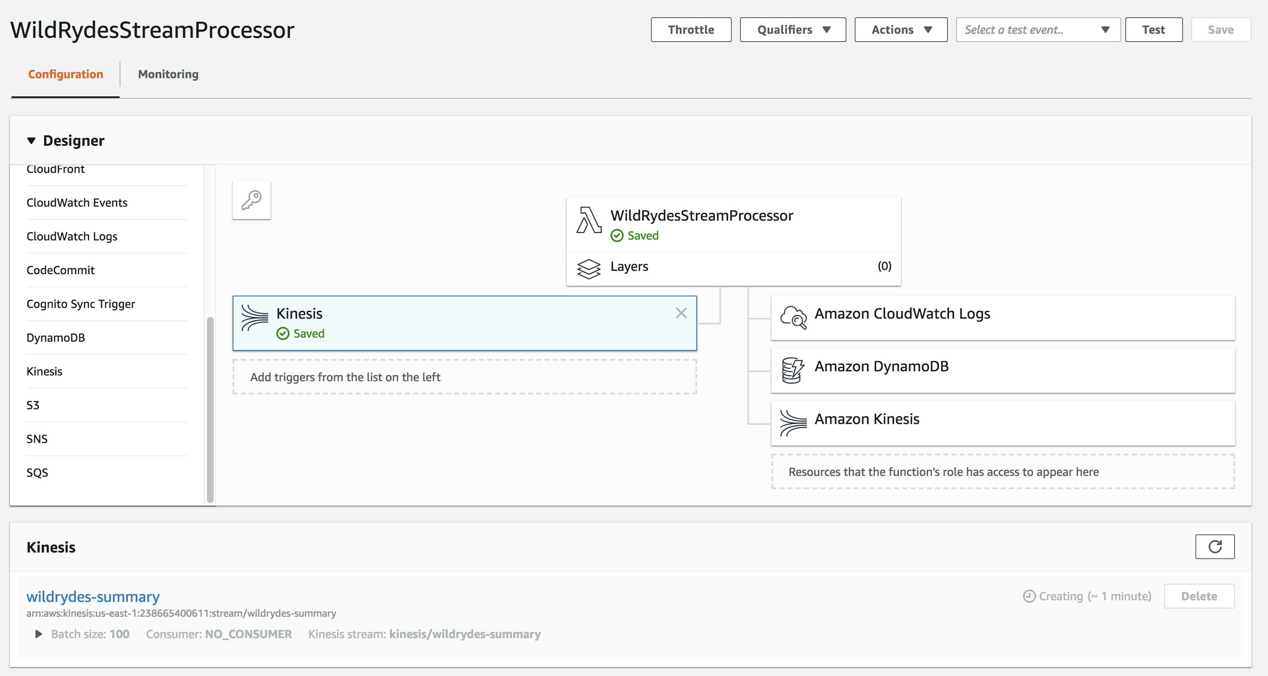

* Lambda function result, logs and items in the DB table

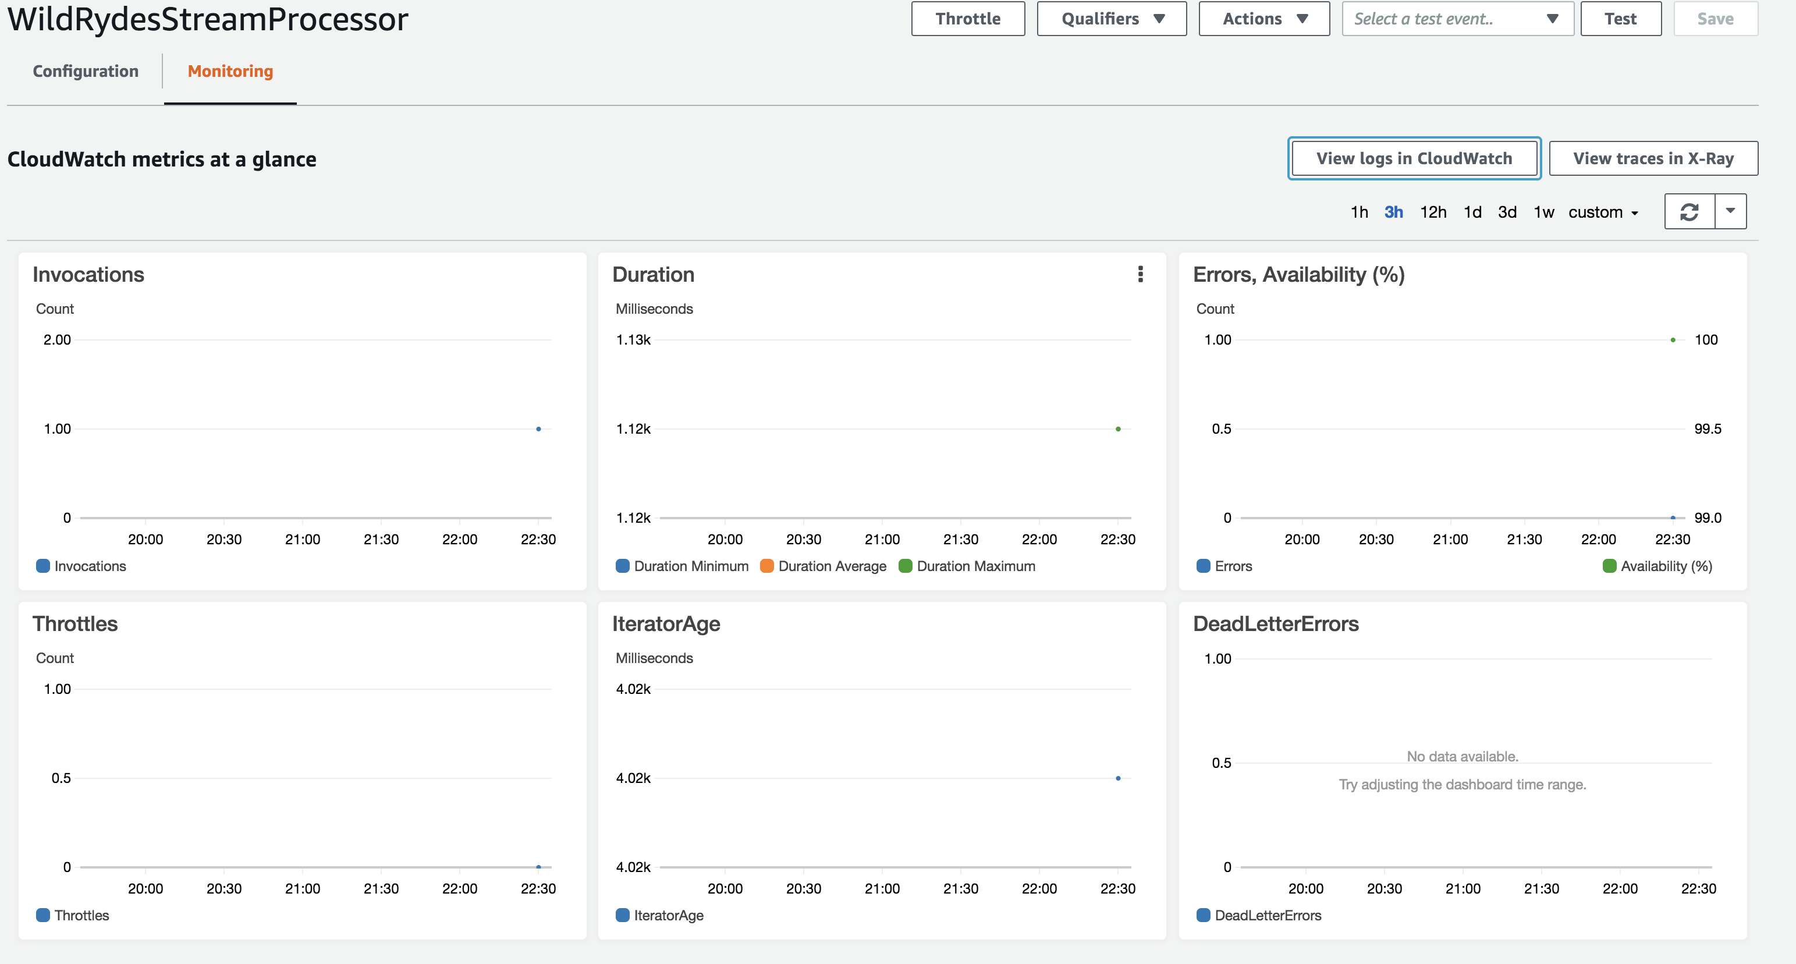

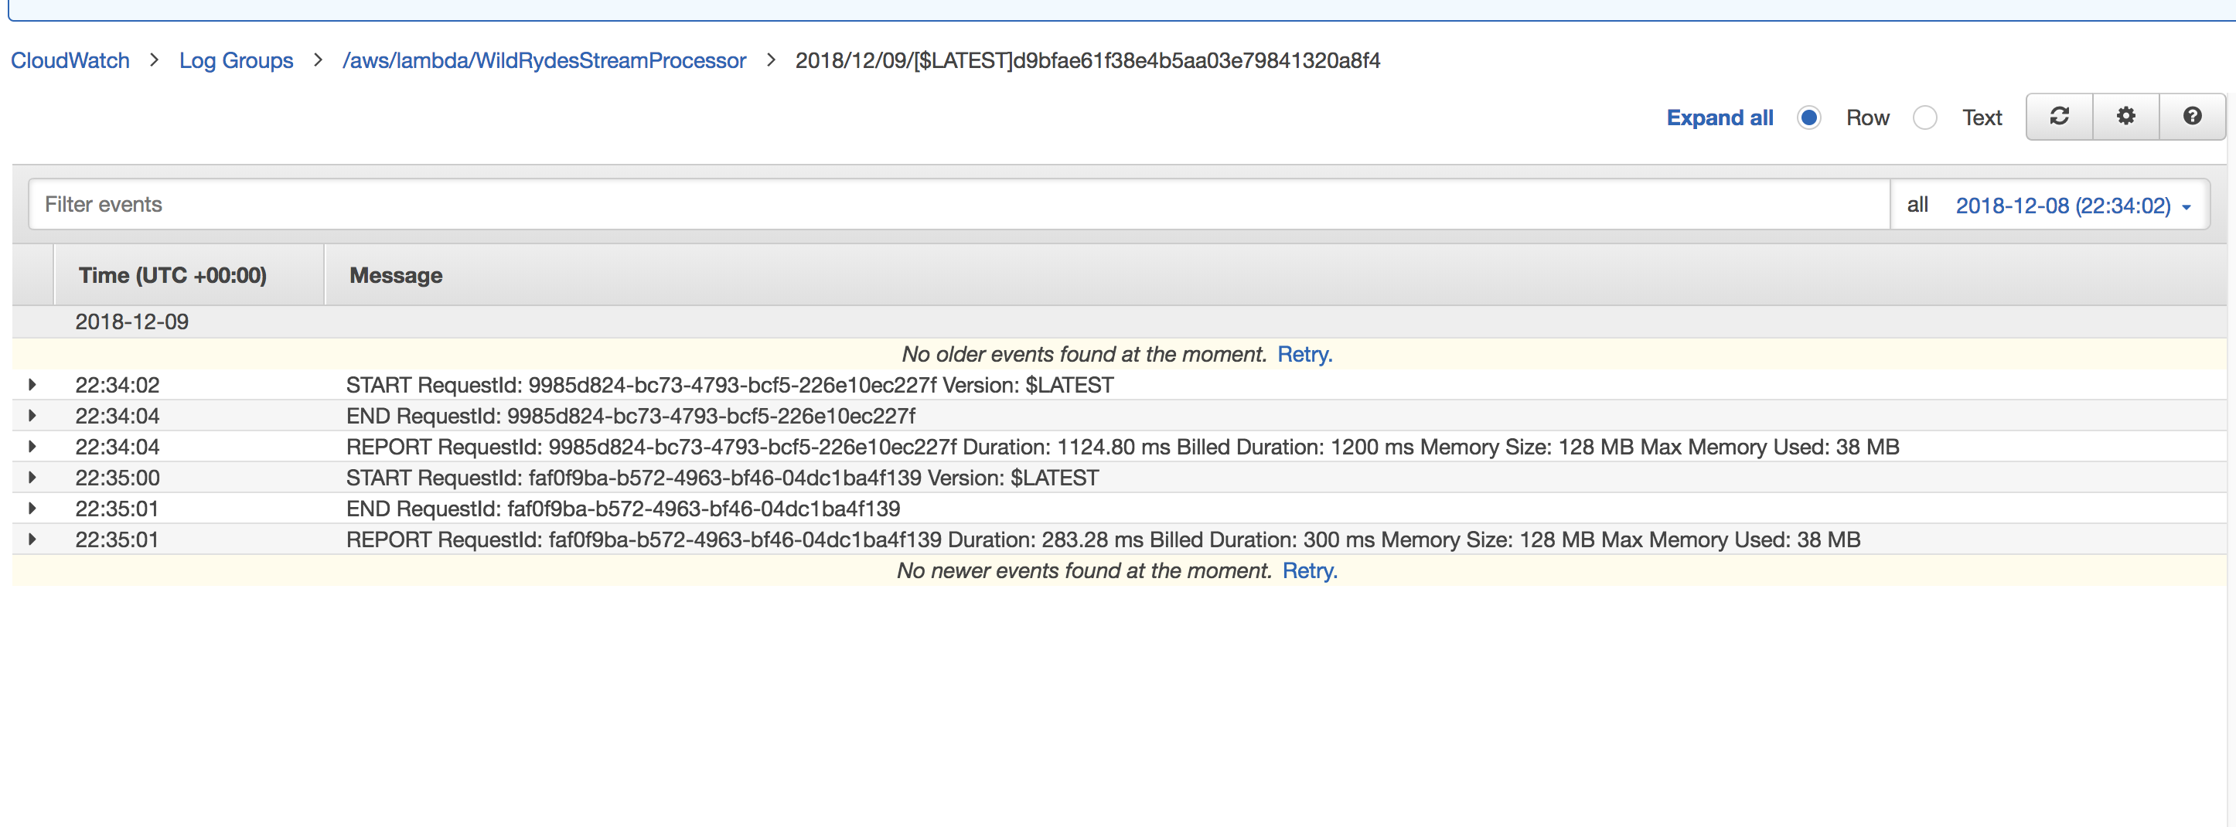

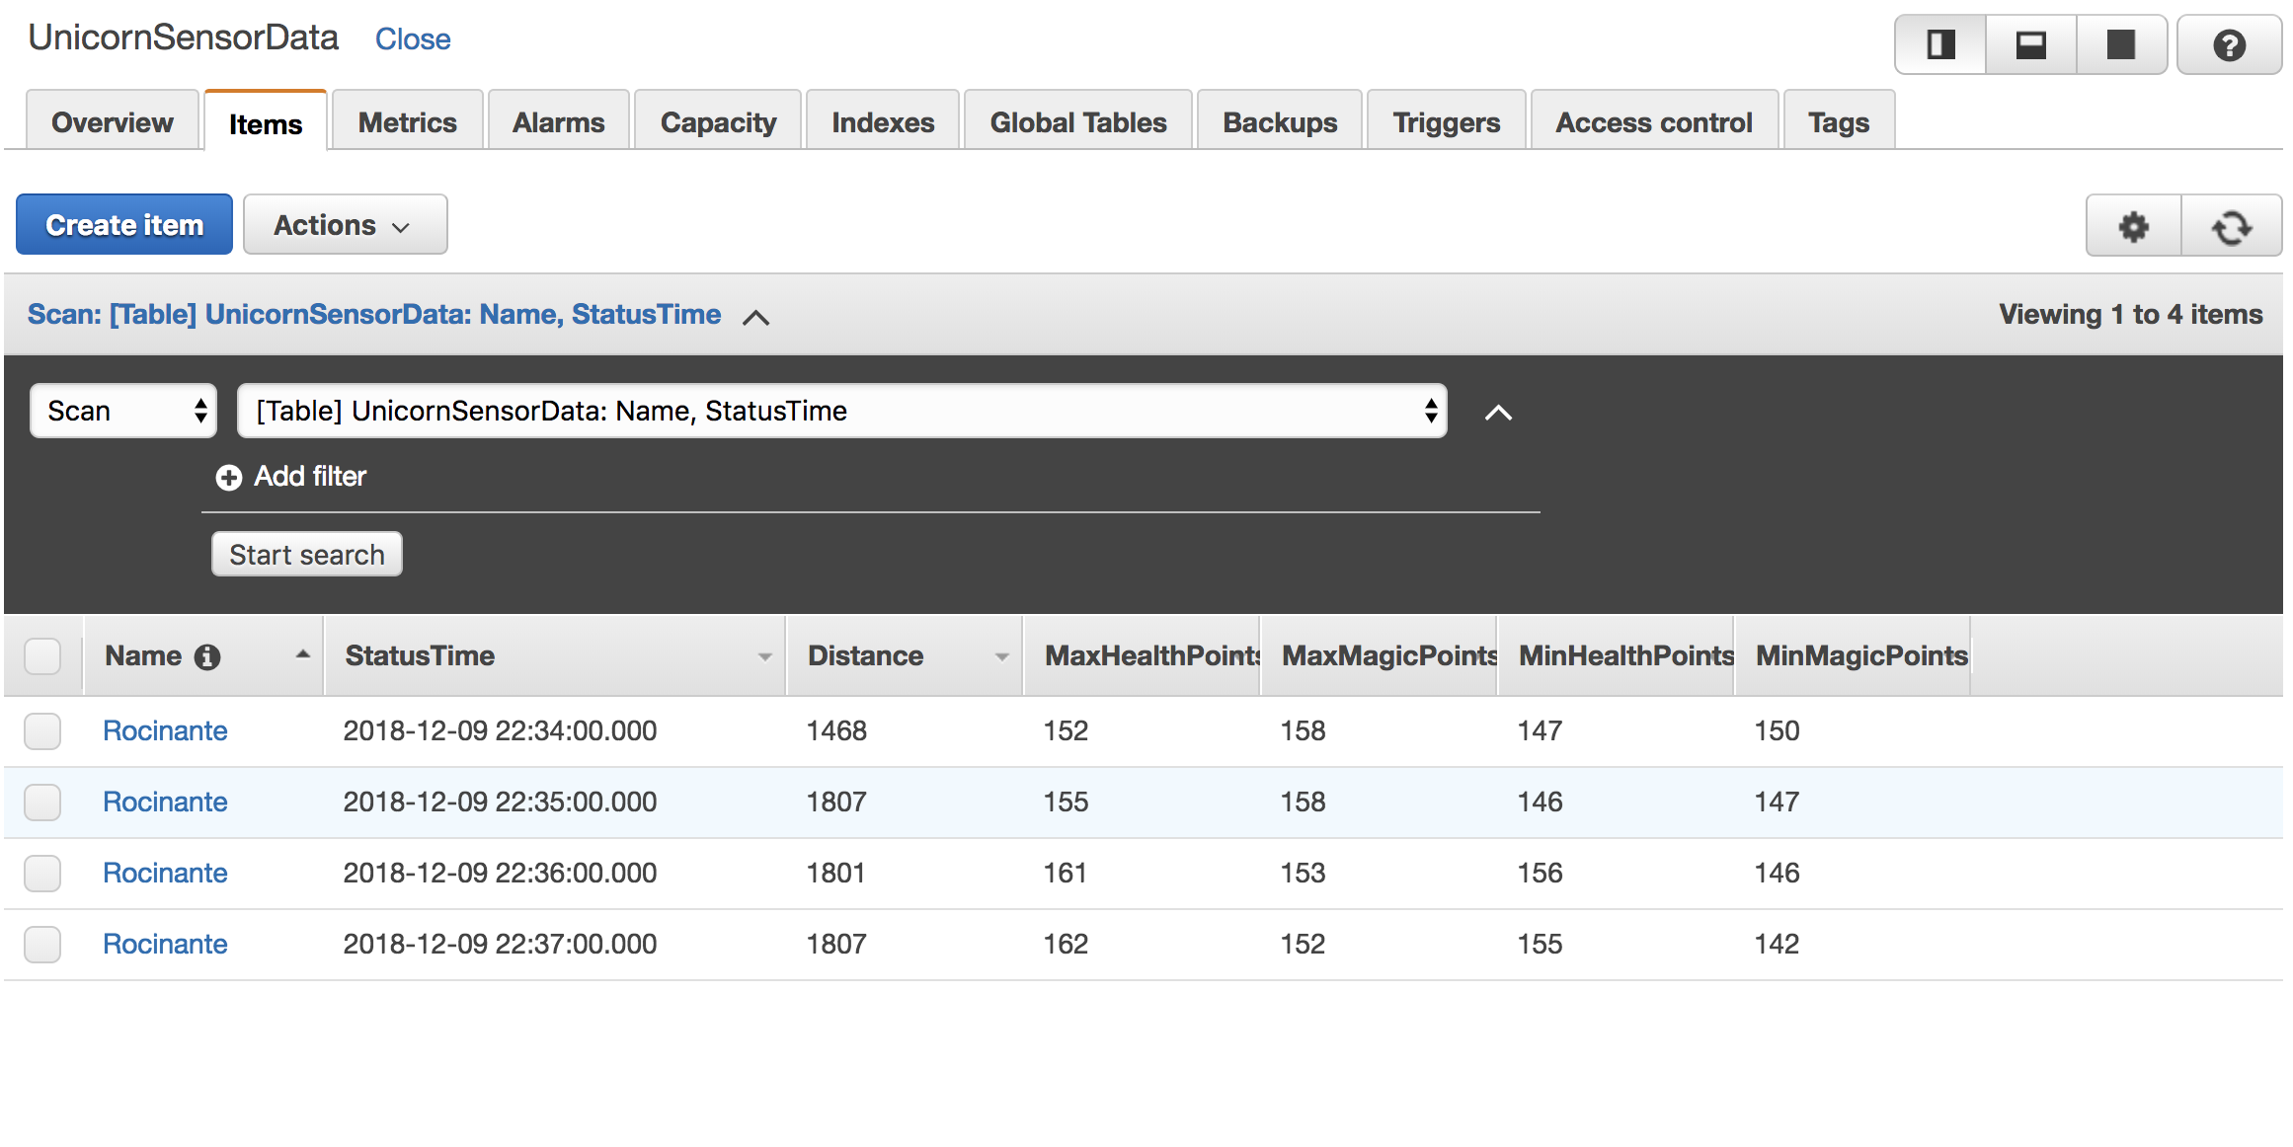

* Query the data in the bucket

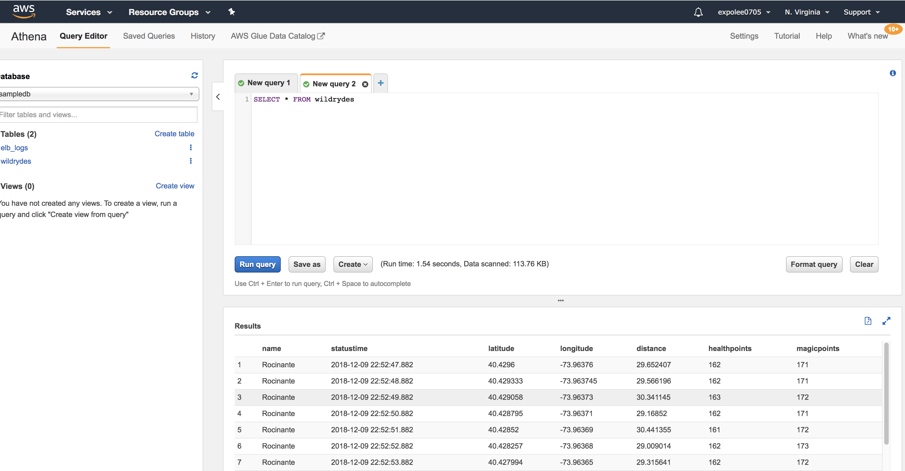

**Summary**

In this project, I learned the three main functions of Amazon Kinesis: Create data stream, analytics application and data firehose. Besides, I learned use Amazon IAM to create different roles and how to add different policies to it, which is important for cloud services. After the combination of them, I finished this serverless real-time data processing application.